Girls Health Matter Project
AdeGrange Child Foundation (ACF), a non-governmental organization committed to addressing strategic interventions and advocacy for combating the challenges facing children and women in Africa, seeks to focus on the developmental life skills with the involvement of parents, communities, governments, and institutions working together to improve health conditions of students will create a powerful impact on their health care-seeking behavior.
ACF seeks to help empower female youths in peri-urban schools (public schools) as our organization is designing and organizing a school hygiene project: “Girls Health Matter.” “Girls Health Matter” agenda is intended to improve the behavioral and hygienic lifestyle of young females in peri-urban schools.
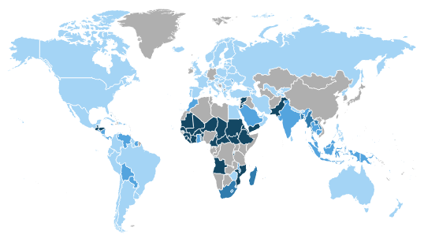
The map shows the rate of out-of-school girls around the world with the darkest blue highlighting the most out-of-school girls.
Studies show that young schoolgirls use improper materials to manage their monthly menstrual flow and/or opt to skip school by staying at home or away from the public which results in missing school at least 3-4 days during their menses. According to UNESCO, 131 million girls are out of school and 100 million of those are girls of high school age. A 2014 report shows that in Sub-Saharan Africa, about 58% of upper secondary school aged youths drop out of school. Based on this report, girls are more likely to drop out of school than boys and while there are many reasons for this discrepancy, female menstruation plays a key role.

WHAT IS MENSTRUAL HYGIENE MANAGEMENT?
UNICEF defines Menstrual Hygiene Management (MHM) to be “women and adolescent girls use a clean material to absorb or collect menstrual blood, and this material can be changed in privacy as often as necessary for the duration of the menstrual period. MHM includes soap and water for washing the body as required, and access to facilities to dispose of used menstrual management materials.”

Many schoolgirls have little to no option but to rely on improved and unhygienic materials to absorb their menstrual flow. Options such as newspaper, rags, scraps of old clothes/mattress, homemade absorbent napkin made of cow dung--materials that are neither hygienic, comfortable nor effective. With frequent leaks and susceptibility to infections, the dilemma reduces most schoolgirls’ experience of menstruation to a monthly dose of shame, discomfort, and frustration. In addition, the absence of clean water, private bathrooms or changing rooms, and sanitary materials in schools adds to the aggravated issue.

UNICEF estimates that 1 in 10 girls in Africa do not attend school due to their monthly period. The reality of socio-cultural restrictions that surrounds menstrual practices prevents young schoolgirls from assessing accurate and critical information and facts about menstrual hygiene. It is very important that schoolgirls and young women have proper and accurate knowledge, facility and safe environment that will allow them to manage their menstruation hygiene, accept their natural body change without feeling ashamed and boost their confidence into womanhood.

ADEGRANGE CHILD FOUNDATION PRIORITIES FOR MENSTRUAL HYGIENE MANAGEMENT
In October 2019, AdeGrange Child Foundation sought out to develop a school hygiene project that would address the behavioral and female hygienic lifestyle of young schoolgirls in selected peri-urban schools in Abuja, Nigeria. During the implementation period, ACF noted that girls in peri-urban or rural schools have poor menstrual hygiene management. We decided to conduct a pilot program on Menstrual Hygiene Management in Girls Secondary School Kubwa and Girls Secondary School Byazin, in Abuja, Nigeria with the introduction of reusable sanitary pads.

The pilot project was established to empower young schoolgirls on the importance of maintaining personal and environmental cleanliness as they reach reproductive maturity. Low socioeconomic status coupled with challenges of assessing good menstrual products are some of the factors that hinder young schoolgirls to manage their menstrual flow, a natural occurrence, with pride and in a safe and hygienic way.

In essence, the pilot project is a pathway for ACF to engage in participatory, evidence-based methods that will provide a pathway for recommendations to help guide future work and advocacy strategy for decision-makers. However, our biggest goal is to create and implement an MHM-healthy school by addressing the barriers schoolgirls and female teachers face in peri-urban and rural areas. The pilot project is created to fill the gap of school health by addressing MHM and puberty education, empowering young girls, and providing guidance and/or toolkits that spell out clear action for administrations and advocates on addressing the deficiency. In addition, this project follows a trajectory of collecting quantitative data as there are limited existing measurements of locating avenues for improvements.

BACKGROUND
The mission of the pilot project, “Girls Health Matter” is to ensure young schoolgirls in peri-urban and rural schools in Nigeria are educated on proper feminine hygiene and menstrual health; to contribute to UN SDG of improved access to safe, sustainable supplies of potable water, adequate sanitation, and hygiene education. The objective is to combat stigma which is central in providing menstrual hygiene management. The pilot project reveals some issues that that we seek to address such as:
- Socio-cultural beliefs and taboos surrounding menstruation
- Current menstrual hygiene practices in schools
- Educating of puberty and menstrual issues in schools
- Education on female body changes, emotions, and natural acceptance.
- Body positivity and respect.

The project introduces reusable sanitary pads provided by Days for Girls, a nonprofit organization in the United States, but serves across the globe. The organization’s goal is to provide “access to menstrual care and education by developing global partnerships, cultivating Social Enterprises, mobilizing volunteers and innovating sustainable solutions that shatter stigma and limitations for women and girls.”

DATA METHOD
We created a 24-question survey for participants to fill out. The survey was printed out in paper form and was provided to the participants to fill out after initial introduction with the participants on the purpose of the visit.

DATA RESULTS
A total of 100 students were gathered at the school assembly grounds to prompt the goals and objectives of the organization visit to each school. The questionnaire was created to measure and assess the outcome towards menstruation at a young age: menstrual knowledge, menstrual practice and attitude, school absenteeism, timing and cycle length and self-esteem.

CONCLUSION
We noticed that out of the 100 students surveyed, we had a few students refuse to respond to the survey in the duration of the survey, either missed questions, survey fatigue or refusal to participate. Prior to ACF arrival to the school, students were to provide a signed document from their guardian or parents giving them permission to participate in the program as some conversations would involve sex education. Of the students that did not sign, they indicated that they were 18 years or older, therefore a signatory from a parent or guardian was not required. However, these students were not exempted from participating. Two students left the conference as their parents happened to be in school and pulled them out of the conference due to reasons unknown.

Introduction
There is a knowledge gap between menstrual hygiene management (MHM) and sanitation systems in schools. Inappropriate usage of sanitary products/materials can result in public health issues.
Objectives:
- To study the awareness about menstrual hygiene to adolescent girls.
- To find out the status of menstrual hygiene among adolescent girls.
- To elicit belief, conceptions about menstruation among adolescent girls.
- To assess the need for improved options for disposal of sanitary materials/products.
- To study the impact of social factors on menstrual hygiene practices.
The Girls Health Matter Project mirrored the Health Belief Model (HBM) which was developed by social scientists in the U.S. Public Health Service in order to understand the failure of people to adopt disease prevention strategies or screening tests for the early detection of disease.
- The HBM suggests that a person's belief in a personal threat of an illness or disease together with a person's belief in the effectiveness of the recommended health behavior or action will predict the likelihood the person will adopt the behavior.
- The HBM derives from psychological and behavioral theory
  - the desire to avoid illness, or conversely get well if already ill;
  - the belief that a specific health action will prevent, or cure, illness.
There are six construct of the Health Belief Model:
- Perceived susceptibility - a person's subjective perception of the risk of acquiring an illness or disease.
  - There’s a wide variation in a person's feelings of personal vulnerability to an illness or disease.
- Perceived severity - a person's feelings on the seriousness of contracting an illness or disease.
  - Often a person considers the medical consequences (e.g., death, disability) and social consequences (e.g., family life, social relationships) when evaluating the severity.
- Perceived benefits - a person's perception of the effectiveness of various actions available to reduce the threat of illness or disease (or to cure illness or disease).
  - A person takes in preventing (or curing) illness or disease relies on consideration and evaluation of both perceived susceptibility and perceived benefit, such that the person would accept the recommended health action if it was perceived as beneficial.
4. Perceived barriers - a person's feelings on the obstacles to performing a recommended health action.
- The person weighs the effectiveness of the actions against the perceptions that it may be expensive, dangerous (e.g., side effects), unpleasant (e.g., painful), time-consuming, or inconvenient.
5. Cue to action - the stimulus needed to trigger the decision-making process to accept a recommended health action.
- These cues can be internal (e.g., chest pains, wheezing, etc.) or external (e.g., advice from others, illness of family members, newspaper articles, etc.).
6. Self-efficacy - a person's confidence in his or her ability to successfully perform a behavior.
Method
Schools located in Peri-urban or rural areas in Abuja local government were selected based on specific criteria to be eligible for the provision of reusable sanitary pads. Due to unforeseen circumstances, only two schools out of eight qualified to partake in the project.
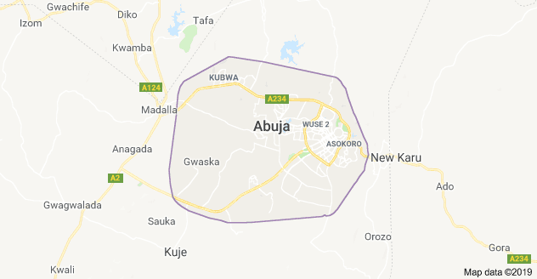 Map of Abuja, Nigeria
Prior to the project kickstart, a focus study was conducted to assess the needs of the students as well as prepare as an organization prior to the project launch. A sample size of 50 female students was randomly sampled with the criteria of the students being adolescent girls who are yet to start their periods or first timers (menache). Sampling was conducted in two stages:
- First stage, sampling will be done in which school administrators will select 20-25 female participants willing to participate in a focus group. The focus group ranges from adolescents who are yet to start their period, those who are first time and those who have already started.
- Second stage will be a convenient sampling of 50 participants that are first timers or yet to experience puberty from selected schools.
As a randomized study, we realize that with the small sample size, the study will provide a good introspect as to what’s to be expected during the pilot project where 100 female students were to be assessed. Survey questions uploaded into the Mobenzi Researcher software platform which will be accessed and analyzed securely.

Interview Method
Initial Focus Groups
- 30-45 minutes
- ~5-10 per group
- Gender-specific
- Translated (if interview is done in a different language)
Target audience
- School girls starting their period for the first time (menarche) AND school girls who are yet to start their period.
- 2-3 Selected male & female teachers in each session.
- 1-2 School Administrator in each session
After Initial, another in-depth interview
- 15-30 minutes
- More in-depth
- Translated (if interview is conducted in a different language)
Target Audience
- Selected school girls starting their periods for the first time (menarche ) AND schools girls who are yet to start their periods.
- 2-3 Selected male & female teachers
- 1-2 School Administrator
Interview topics focused on beliefs, cultural traditions, knowledge, challenges, impact, facilities, and community/Family Support.

Results
Absenteeism in School
Proportion of participants reporting using different menstrual practices according to location in survey of schoolgirls in Abuja, Nigeria (n= 100). Based on the response, we see that students are not likely to miss school due to their menstrual flow. This illustrates that most have access to feminine products or have support that would aid them in attending classes during their menstruation flow. Some are more likely to miss school due to some quantitative reasoning provided such as: getting their period for the first time or religion practices.

Types of materials
The type of menstrual material used was asked to assess how the materials the organization provided would fit into best and sustainable practice. Furthermore, to capture their understanding of what feminine hygiene products are available based on their location, we asked knowledge questions about some feminine products.
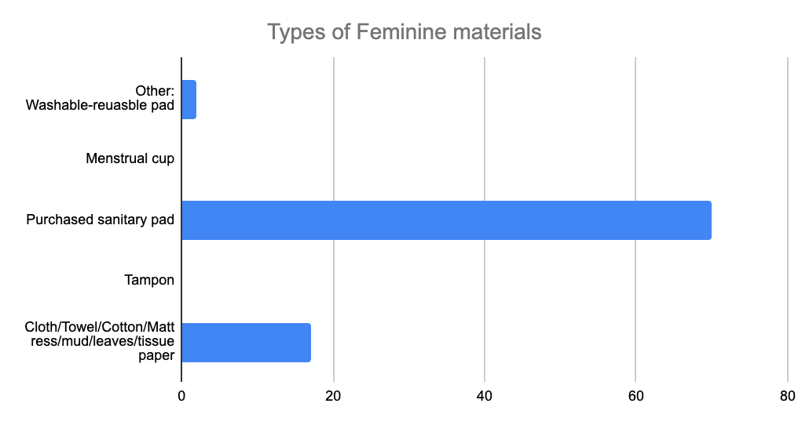

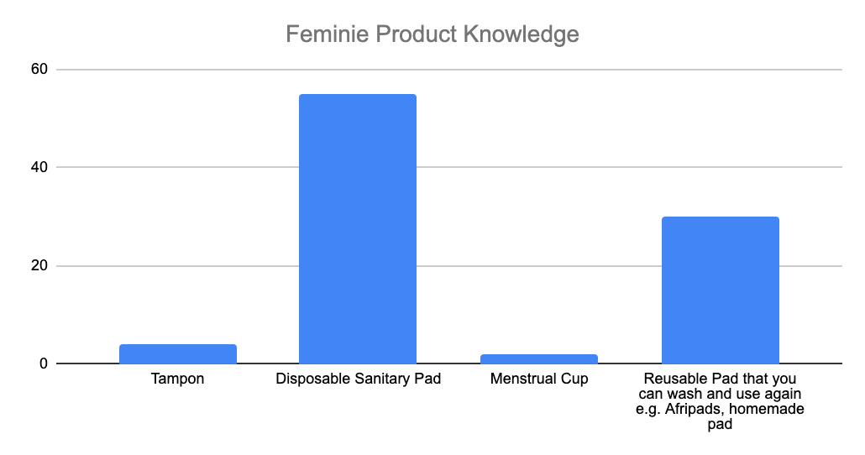
Based on the survey responses, 79% indicated access to commercial menstrual pads. This illustrates that these students are in a setting where disposable sanitary products are already widely accessible and used.

Social expectation
Lastly, we want to gauge the association between menstrual practices and social outcomes. Most students indicated that their menstrual flow did not affect their confidence in any form. They do not feel the need to hide under pressure or conceal themselves because they are able to adapt.

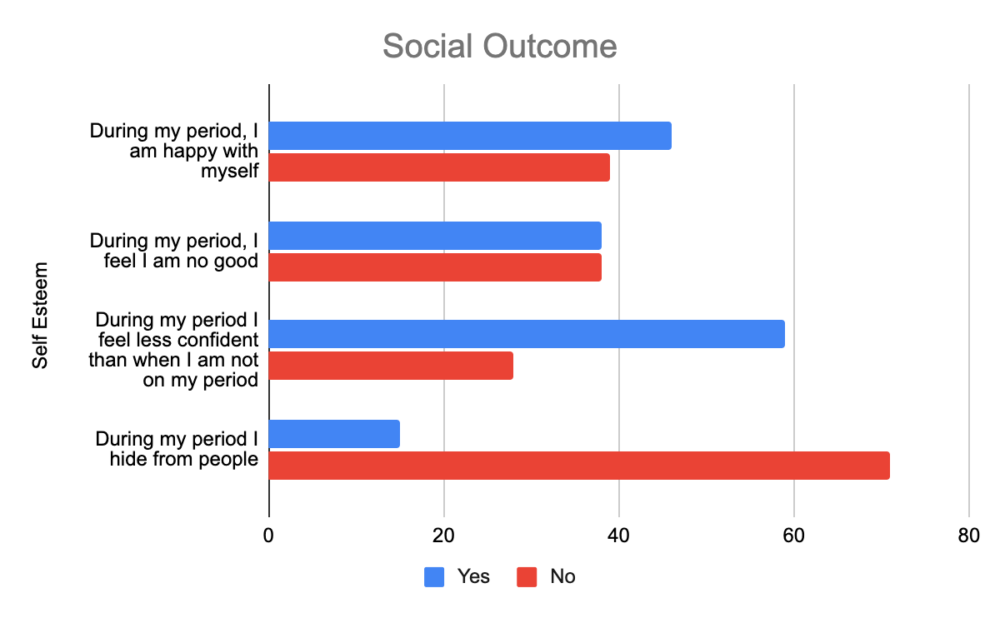
*A student commented that she saw her period for the last 3 months and hasn't seen it afterwards.

Discussion
Days for Girls, Aurora, Illinois Chapter, agreed to supply the organization with the reusable sanitary kits. Each kit includes absorbent liners, a carry pouch for washing and storing, washcloth, panties, soap, waterproof shields, care and use sheet and a drawstring bag to hold components. Each AdeGrange staff went through a series of training to learn about how the kits are to be used and distributed.
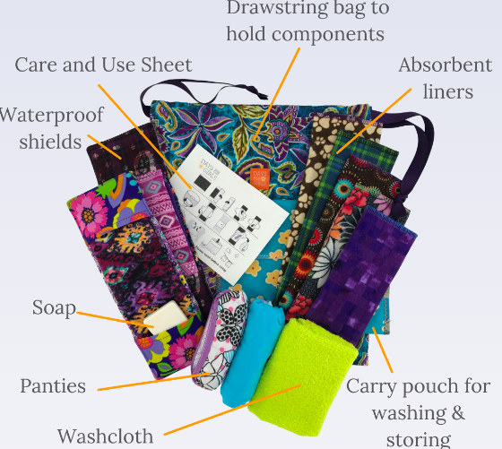

From the study, we see that menstruation does not affect the overall livelihood of the female students. It is important to note that these students are aware about the social norms and adhere to the social etiquette that comes with treating menstruation as a private matter, however, their overall indication on the survey shows that they are conscious of the matter and have access to resources to aid them during their monthly flow.

Even though quantitatively the survey accounts for the reality of the students’ response, we have to take account of the perceived barriers shared by the students during discussions. Most students indicate that the availability of disposable sanitary pads in their region is problematic.
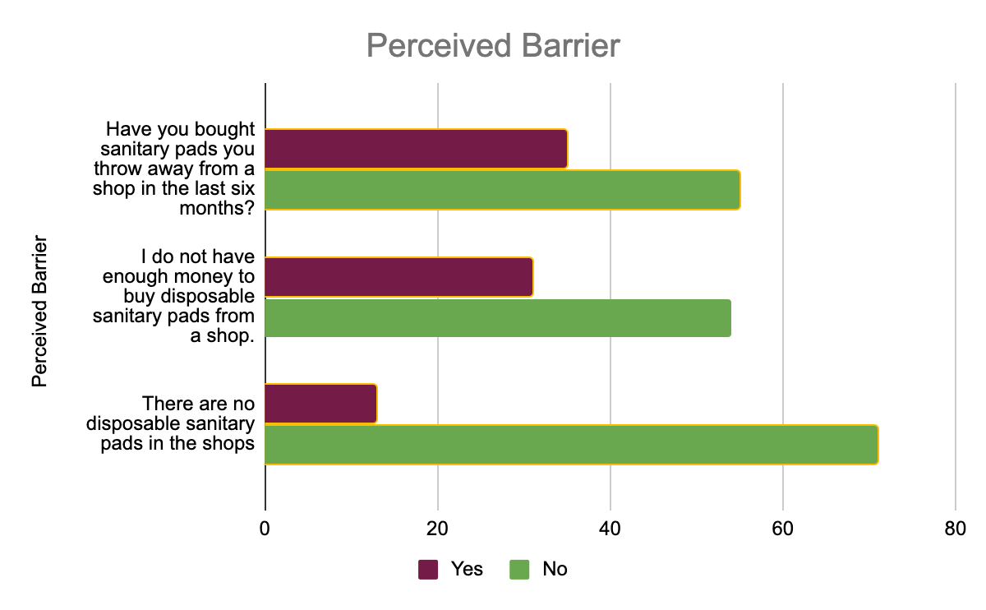

Examples of qualitative findings from the project:
Knowledge – “I was scared when it first happened because I had never heard about it before.” “I don’t know why [menstruation occurs].”
Challenges – “Supplies are so expensive and we can’t afford them. You become embarrassed especially if the opposite sex finds out.”
What’s Needed? – “We need help with supplies at school because it’s embarrassing in front of boys. Usually girls just go home with no supplies.”
Parents/Admins
Impact – “Younger children don’t come to school – they fear boys will notice and laugh. We still encourage the old women to teach the traditional system so they know what to do before they grow up.”
Teachers
What’s Needed – “Providing pads, soap, and water heads so they can change at school and bathing shelters just for the school girls and bins for washing. They should come up with a certain group for educating girls on certain health matters.”
Based on the responses from the focus group questions and discussions, program administrators paid close attention to consistent findings:
- Few resources (emergency supplies, facilities)
- Low knowledge base (women and girls)
- Scarce community support
- Traditional beliefs/restrictions
These lead to:
- Uncomfortable feelings among school girls
- School absenteeism
- Unhealthy MHM practices, as shown in the graph under the “results” section.

Limitation
The project recognizes the limitation of using the Health Belief Model as it does not take into account:
- a person's attitudes, beliefs, or other individual determinants that dictate a person's acceptance of a health behavior.
- behaviors that are habitual and thus may inform the decision-making process to accept a recommended action (e.g., smoking).
- behaviors that are performed for non-health related reasons such as social acceptability.
- for environmental or economic factors that may prohibit or promote the recommended action.
It assume that:
- Everyone has access to equal amounts of information on the illness or disease.
- cues to action are widely prevalent in encouraging people to act and that "health" actions are the main goal in the decision-making process.
Therefore, the questionnaires posed to the students were tailored to be relatable and equitable in order to have a fair assessment of the students' needs.

Additionally, the survey questions could have been shortened as some questions felt repetitive. This could have accounted for survey fatigue as most students did not answer all 24 questions from the survey. Survey was also conducted on assembly grounds where students were standing to write in their response compared to sitting in a more comfortable environment. We perceive that their response was rushed to write down as they were eager to start the program.

Conclusion
Unfortunately, due to the 2019 Pandemic of COVID-19, AdeGrange was unable to do a follow up study with the students after 6 months of usage of the reusable sanitary pads. When program administrators followed up with each school, they reported back that most students who participated in the program were no longer attending the schools where the project was conducted, some dropped out of school as an effect of the pandemic, and some graduated. We hope we are able to continue this project, if not in similarity, in the future as we are focused on evidence based approach to conduct needs assessments that’ll determine how AdeGrange Child Foundation can be a resource to the needs of the community across Nigeria.

Reference
https://www.ncbi.nlm.nih.gov/pmc/articles/PMC7594862/

“Behavioral Change Models.” Behavioral Change Models, sphweb.bumc.bu.edu/otlt/MPH-Modules/SB/BehavioralChangeTheories/BehavioralChangeTheories_print.html.

Daysforgirls.org

